Kent State University

MIS-64018: Quantitative Management Modeling

Fall 2019

Milk Inventory Stocking Levels



Authors:

Cameron Croghan (Student ID: ccroghan)

Charity Elijah (Student ID: celijah)

Steven Spence (Student ID: sspenc12)

**Abstract**

The milk industry is seeing a significant change in consumer preference. Dairy milk demand is decreasing 2.4% annually, while plant-based milks are increasing 5.6% annually. As a result, retailers and farmers are dumping millions of gallons of oversupplied milk. This project outlines the appropriate product mix and stocking levels for milk over the next three years.

**Table of Contents**

Background Information 4

Problem Description 5

Data Overview 6

Solution Approach 9

Interpretation of Results 14

Recommendations 15

References 16

# 

# Background Information

In the early 1990’s, the “Got Milk?” advertisements were a prominent influence on consumer behavior to purchase cow milk. Well-known athletes were shown drinking a glass of milk and then making the game-winning shot at the buzzer. It fed consumer’s desire to be like their elite role models. Partly due to this advertising campaign, the dairy milk industry sales remained strong throughout the decade. However, subsequent decades have seen a steady decline in sales.

Many attribute this decline in demand for cow milk to the plethora of plant-based milks entering the market: almond, soy, coconut, rice, quinoa, etc. These plant-based milks are derived from a variety of sources: nuts, seeds, legumes, and cereal grains to name a few. Based on the feedback received from non-dairy consumers, allergies, lactose intolerance and preference for a vegan-based diet have been driving forces influencing both the decline in cow’s milk demand and rise in plant-based milk sales [1]. As a result, retail outlets, distributors, and farmers find themselves struggling to meet the changes in market demand.

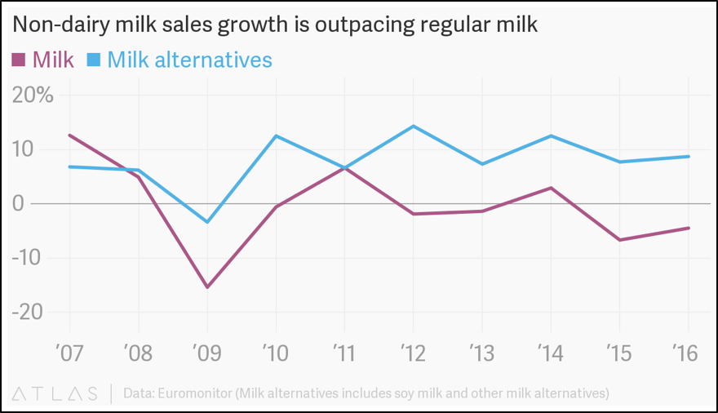

Chart showing the change in demand for cow milk and plant-based milks since 2007 [2].

The chart above shows the change in milk demands since 2007. From the chart, it is clear that plant-based milks have outpaced cow’s milk demand consistently since 2009. Similarly, cow’s milk has seen a consistent decline in demand since 2011. In that same timeframe, plant-based milk have seen a consistent positive increase in demand. The chart below expands on this timeframe to include the past several years. As shown in this chart, there is still a clear increase in plant-based milk and decrease in cow’s milk demand. There appears that this trend will continue for the foreseeable future, so industries need to pivot their strategies to survive.

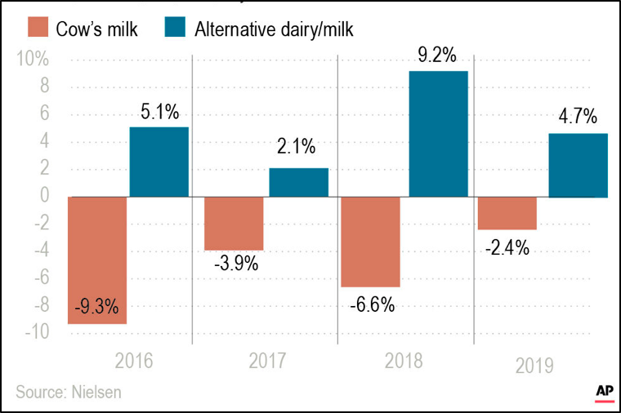

Chart shows the change in demand for both types of milk for the past several years [3].

This significant change in demand of the market has also caused problems determining optimum stocking levels for dairy products. Ultimately, improper stocking of store levels can lead to oversupply, which will result in wasted, expired milk gallons. On the other hand, undersupply can lead to lost sales for the retail outlet. Therefore, it is a delicate balance between meeting the demand, eliminating waste, and planning for the future stocking levels.

# Problem Description

The previously described trends highlight the emerging challenges with dairy milk supply and wastage on a national scale. Milk wastage happens in numerous areas of the supply chain. The production process itself has a lot of sources of waste. The distribution process can lead to waste due to inefficient processes. Improper storage of milk can also lead to wasted milk. Lastly, overproduction and shelf-life laws also lead to a large amount of waste. In regards to overproduction, there was a reported 43 million gallons of cow’s milk was dumped by U.S. farmers due to overproduction in 2016 alone [4]. Therefore, it is imperative to capture the voice and demand of the customer at the retail level, so that upstream processes can accommodate and adjust their processes to meet the ever-changing demands.

Due to changes in market trends, farmers, distributors, and retailers alike are experiencing significant amounts of waste from overproduction and oversupply of certain types of milk. As such, this project sets out to determine the optimal yearly product mix (for dairy and non-dairy milk) to maximize sales dollars for retailers while minimizing the quantity of expired unsold milk. Retailers would like to know what quantity of dairy milk to carry as inventory relative to the non-dairy milk. Therefore, we set out with the following project objective: Given the average change in demand for dairy and non-dairy milks, what quantity of each type of milk should a retail outlet stock on a daily basis? The solution to the problem should enable retailers to better manage inventory of dairy and non-dairy milk and not overstock these products resulting in wastage and unsold product. This will also allow farmers and distributors to plan accordingly for future levels ordered by stores in a particular region.

Although the problem is a national issue impacting all stores and farmers, the scope of this project will be narrowed down to a particular, single city region for analysis. The time-frame, monetary requirements, and personnel limitations require the team to narrow the scope down for initial analysis of the market. As a result, the market analysis and problem statement will be focused on the Kent, Ohio region and a single store with a target population of approximately 30,000. Additionally, only the top four milks by sales for each type will be utilized in the model: whole, two-percent, one-percent, skim, almond, soy, coconut, and rice milk. This will allow the team to get a functional model that can be tested on a smaller scale before increasing the scope and adding additional variables into the calculations for store stocking levels.

# Data Overview

There were several data sources cited for the scope of this project. At the time of project creation, the investment in a formal industry reports for dairy milk and plant-based milk could not be justified; therefore, some assumptions and boots-on-the-ground approach to data collection were utilized. Additionally, to narrow the scope of the project to a manageable starting point, only the top four dairy milk types (whole, two percent, one percent, and skim) and top four plant-based milk types (almond, soy, coconut, and rice) will be analyzed. The following paragraphs will outline the scope, assumptions, and calculations used to get our baseline values for demand, shelving space availability, and proportion of sales.

As stated in the introductory sections, the demand for dairy and plant-based milk are trending in opposite directions. The total sales for dairy milk in 2018 was collected from the United States Department of Agriculture. In 2018, total dairy milk sales for whole, two percent, one percent, and skim milk were 42.3 billion pounds [5]. Milk is typically sold in gallon containers at retail locations, so this value had to be converted. The average weight of a gallon of dairy milk is 9.10 pounds; therefore, the sales in gallons for 2018 was 4.65 billion gallons. Whole milk accounts for 39% of the sales, two-percent milk is 36.6% of the sale, one-percent milk is 15.6% of the sales, and skim milk is the remaining 8.7% of sales. These values will be used in the following section when structuring the solution approach.

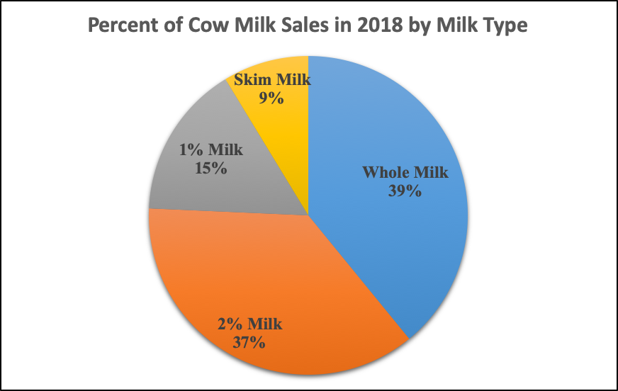

Visual representation of cow milk sales by type for 2018.

The same process was utilized to get the previous year sales for plant-based milks. However, this category had to utilize annual sales dollars and average milk prices to get a rough average for annual sales. This different approach had to be used, because there was no free public sales data in pounds for plant-based milks. According to the data collected, almond milk had the largest portion of the sales in the market (77.3%) at $1.2 billion in 2018. The next largest contributor to sales was soy milk at $215 million (13.8% of the market). These were followed-up by coconut milk at $99 million (6.3% of the market) and rice milk at $40 million (2.6% of the market) [6]. The average price for each milk type was then used to calculate the units sold: $1.82, $2.08, $2.97, and $3.44 respectively. Additionally, plant-based milks are typically sold in half-gallon containers, so that will be the units adopted in this problem. As a result, the annual sales for these four plant-based milks came to just over 800 million half-gallons sold. This value will be further cited in the next section.

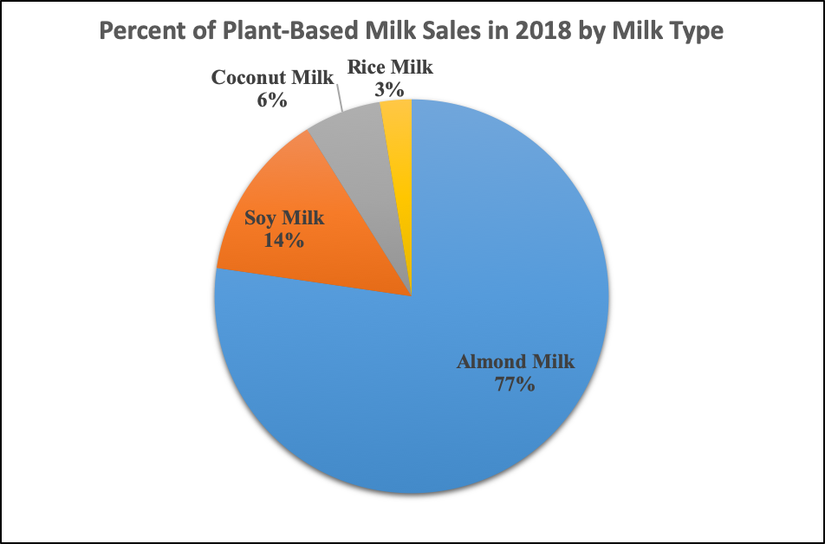

Visual representation of plant-based milk sales by type for 2018.

The second portion of the data collection process was to get the average shelf-space available for milk containers in a retail environment. This was done by physically going to several stores to see how much shelf space was dedicated to milk. The image below shows what the typical cooler looks like. On average, there are a total of eight coolers dedicated to stocking milk. Additionally, each cooler has five shelves available to place the milk on. The measured dimension for each shelf was approximately 605 inch2. Therefore, when you multiply this value by the total number of shelves available, the amount of available shelving space is 24,200 inch2. Lastly, the size of the milk containers needed to be determined. As previously stated, cow milk is typically sold in gallon containers and plant-based milks in half-gallon containers. The bottom surface area of a gallon container measures 30.25 inch2, and the surface area on the bottom of a half-gallon container measures 14.06 inch2. These values will also be carried into the solution description section when it is outlined how to optimize the shelf space.

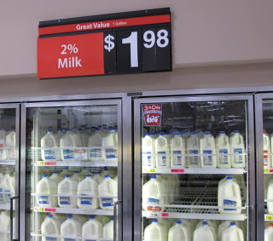 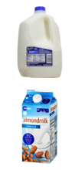

(Left) Image of typical milk coolers at retail store. (Right) Screenshot of a typical milk gallon and half-gallon for reference.

At the time of data collection for the project, there were several pieces of information not publicly available for review. These pieces of information include additional store space available in other areas of the store (i.e. coolers in the back), store profit per unit of milk sold, cost of storing extra milk, and cost of throwing out or selling back expired milk. Therefore, the scope of the project’s decisions variables were simplified slightly for the solution and analysis approach. This information provides a solid foundation for additional analysis once more information is available on the storage and profit items. The following section will delve deeper into the solution approach the team took to find the optimal stocking levels by milk type.

# Solution Approach

The scope of the project was distilled down to a specific, representative store to make the analysis slightly more manageable. The representative store in question is the Walmart located on the southern side of Kent, Ohio. The assumption for this project is that this store serves a population of roughly 30,000 people. We believe this is a safe assumption, because this has historically been the only major grocery store in this region (a new Meijer is currently being built across the street), and serves the population centers of Kent, Tallmadge, Mogadore, Brimfield, Rootstown, and some of Randolph.



Screenshot of the location of the representative store in question.

With this target store in mind, the objective of the project is to advise the store on the optimal milk stocking levels for the upcoming years to maximize sales while minimizing wasted, expired milk. This will be accomplished by completing an integer linear programming model with eight decision variables for the problem. Each one of these decision variables will represent the number of units (gallons or half-gallons) of each type of milk to stock daily. As previously stated, the milk types include whole, two-percent, one-percent, skim, almond, soy, coconut, and rice milk. A visual representation of the objective function is shown below for further clarity.

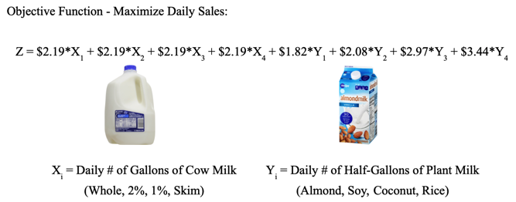

Visual representation of the objective function.

As shown in the objective function, the *X* variables correspond to type of cow milk (*i* = 1, 2, 3, 4) and how many gallons to stock per day. The coefficient for each *X* variable represents the sales price per gallon of milk. In the case of cow’s milk, all four types sell for the same price, which is $2.19. Similarly, the *Y* variables correspond to type of plant-based milk (*i* = 1, 2, 3, 4) and how many half-gallons to stock per day. The price for each type of plant-based milk is different. Therefore, the coefficient for each *Y* variable represents the sales price for that type of milk. Now that the objective function has been outlined, additional constraints were added to account for the average daily demand, available shelving space, and proportion of sales.

The first constraint that will be outlined is the average daily demand. The previous data overview section outlined the process for determining the sales for 2018 and proportion of sales for each type. To reiterate, the cow’s milk sales were at 4.65 billion gallons and plant-based milk sales were at 800 million half-gallons. These values were for the entire United States population (approximately 325 million people). The target market for our store is 30,000, so some additional calculations were required. We calculated the average daily demand per person for each type of milk, and then applied that to the target population to get our maximum daily sales constraint. The image below shows an outline of the constraint for each type of milk.

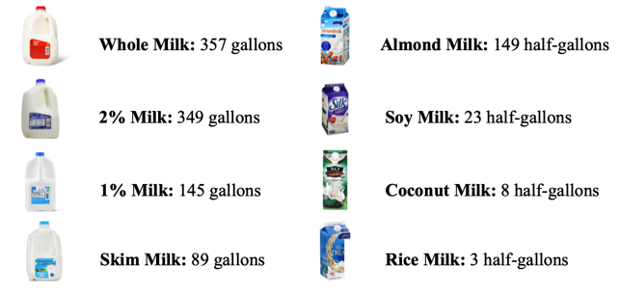

Outline of maximum daily sales for each milk type for our target population.

The maximum daily sales for our target population is 940 total gallons of cow’s milk and 183 half-gallons of plant-based milk. The specific values for each milk type is shown in the image. As expected, whole milk will have the largest potential number of max sales and rice milk with the smallest number of potential max sales based on historical sales data.

The next constraint that was added to the model was the shelving space constraint. As previously stated, the available surface area on the shelf available is 24,200 inch2. The cow’s milk gallon containers take up 30.25inch2 of surface area and the half-gallon containers take 14.06 inch2 of surface area. These values were entered into the linear programming model as to not exceed the available shelving space.

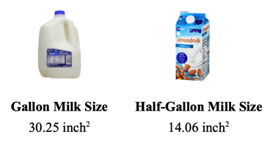

Overview of surface area taken up by each type of milk container.

The last set of constraints added into the linear programming model had to account for the cow’s milk gallons all costing the same amount and take up the same amount of space. If the maximum demand for cow’s milk cannot be met, then the model has no way to prioritize which type of cow’s milk to stock. Therefore, the last set of constraints puts a minimum proportion value (as a percent of the total cow milk) for each type of milk. This means that the mixture of cow’s milk being stocked should mimic the proportions seen in the annual sales.

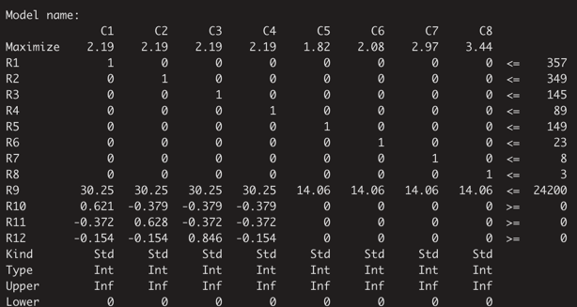

.lp file used to solve the project’s objective function.

As shown in the .lp file above for our linear programming mode, there were several other items we had to specify. One of those items being the type of variable. In this case, all of the variables were specified as integers, because the store cannot sell a portion of a gallon container. The second additional item was defining the lower bound. For this problem, the lower bound was set at zero. The screenshot below shows the output from running our .lp file. The “0” states that the model found an optimal solution. The “1917.13” states the optimal solution to the objective function, which corresponds to a daily sales values of $1,917.13. The last line from the output shows the optimal value for each *X* and *Y* decision variable. The values are arranged the same as the objective function. For example, the first number (271) means that the optimal daily stocking level for whole milk is 271 gallons per day, and the fifth number (148) means that the optimal daily stocking level for almond milk is 148 half-gallons.

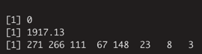

Output from the .lp file used in the project

The decision variables for the linear programming model were set on a daily stocking level; however, stores typically order their stock on a weekly, bi-weekly, or monthly basis. This is mainly due to shelf-life of a product, demand, and current inventory levels. Cow’s milk has a shelf life of only one to two weeks, so our assumption for the project is that the store is ordering on a weekly basis. Therefore, we took the daily values and multiplied them out to a weekly stocking level for the store buyers. The resulting values are shown in the summary image below.

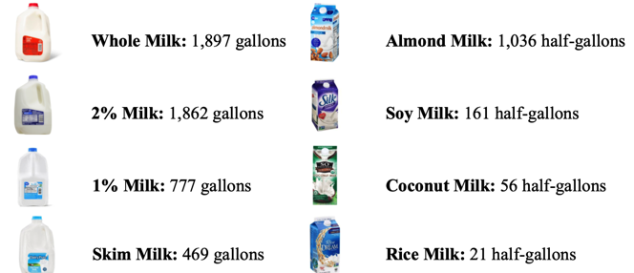

Summary table for optimal weekly stocking levels for each type of milk.

The table above shows the optimal stocking levels for each type of milk on a weekly basis to optimize sales and minimize expired, wasted milk. With these values, the store can expect to meet $13,420 in weekly sales just from these eight milk types. These values can also be extrapolated out to the following two years based on yearly changes in demand. Cow’s milk sales are decreasing by 2.4% per year, and plant-based milk sales are increasing by 5.6% per year. The chart below shows the trends in optimal milk stocking levels for the target store in question for the next several years.

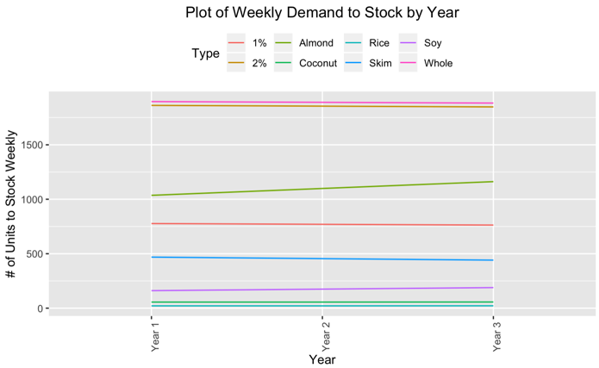

Chart of weekly stocking levels for each milk type adjusted yearly to account for changes in demand.

With the cited changes in demand over the following three years, the store can expect to stock 70 gallons per week less of cow’s milk in year three compared to year one. This would correspond to a decrease of 3,640 gallons for a single target store. Alternatively, the store can expect to stock 156 half-gallons more of plant-based milk in year three compared to year one. This means the store will order over 8,000 more units of plant-based milk on a yearly basis at the end of year three. These values may not be mind-boggling changes in demand on a single-store level. However, if the trend is expanded out to all of Northeast Ohio (population of approximately 4.5 million people, then the change in stocking levels after three years will be 10,500 less gallons of cow’s milk per week. That is over half a million gallons less over the entire year! For the plant-based milks on this scale, the increase in weekly demand will be 23,500 more half-gallon units, which means over a million more units per year just for Northeast Ohio. As the scope of analysis increases, the impact on farmers, stores, and consumers become significantly larger. This impact will be described in more detail in the interpretation and recommendations sections.

# Interpretation of Results

Our model gave us an output that resulted in $1,917.13 in daily sales. When we expand these results to the weekly numbers we are aiming to get, we see that the cow milk outputs are slightly under our demand constraints, while the plant based milk types all met or were very close to meeting their demands. This is partly due to the amount of space utilized by plant-based milks over cow’s milk. Since more plant-based half gallons can fit on the shelf, it is more likely that the demands will be met for this product.

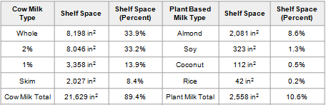

Table showing the shelf space utilized by each type of milk.

The table above shows a summary of the shelf space utilized by each milk type. In regards to shelf space, whole milk and 2% milk took up just over two thirds of the total available shelf space. In total, all of the cow milks took up just under 90% of all total shelf space for our model. Plant based milks only took up 10.6% of the available shelving space. Almond milk took up the bulk of that space with 8.6%.

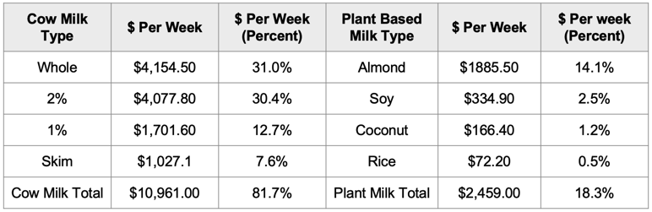

Table showing the sales per week by each milk type.

The table above displays a similar summary table, but for the sales instead of shelf space. When you look at dollar amounts per week for the milk type, plant-based milk performs a lot better in comparison. Cow milk still results in the highest amount of sales, with 81.7% of the weekly sales, and over 60% of that comes from whole and 2 percent alone. Almond milk performs very well, earning more than either 1 percent or skim milk, and is easily the highest of the plant-based milk types at 14.1% of weekly sales.

Plant-based milk types have a shelf-space-to-dollars ratio that is twice that of cow-based milk types. This is the case for two main reasons. First, plant-based milk is usually sold in half gallons instead of full-sized gallons, taking up less than half of the space on the shelves. Second, on average, the price for the plant-based milk is much higher than that of the cow-based milks, which are all set at $2.19 no matter which type of cow milk a consumer is to purchase. Plant-based milks range from $1.82 to $3.44 per unit.

When you change the demand to match the expected shifts over the next few years you see a general decrease in cow-based milk types, while seeing a steady increase in all plant-based milk. For a single store after three years of shifting demand, our model shows that they will carry 70 less cow-based gallons of milk per week, while increasing the number of plant-based half gallons by 156 per week. While individual stores don't have to make any dramatic changes any time soon, that is not the case for the farmers who need to produce the milk. In Northeast Ohio alone, our model tells us that cow milk will have a decrease of 10,570 gallons per week, while 23,556 more half gallons of plant-based milk will have to be produced. With the steadily declining number of cow-based milk demand, farmers may want to re-evaluate their crop and dairy mix to accommodate this changing demand.

# Recommendations

After reviewing the results from this project, the team has several recommendations for improving the model accuracy, as well as for the milk industry as a whole. First, in regards to improving the model accuracy, there are several items that can be researched and added to the model. One item would be to get an actual profit per unit of milk. For this project, the information was not available; however, if the profit was known for each type of milk per region, then the objective function could be changed to maximize profit. Additionally, more demographic information needs to be collected. A research study on the milk preferences and quantities by age, gender, region would significantly improve the accuracy of the demand for a particular region. Additionally, transportation, inventory storage costs, and cost of unsold milk would be great information to have. This would allow us to add additional variables into the model to account for the additional costs not included in this model. The shelf-life of each type of milk could also be included in the model while adding a penalty for anything under/over the constraints. Lastly, the addition of different sized milk containers could also help improve the accuracy of the model. Milk can be sold in half-gallon and quart containers, so this would add some additional flexibility to the model.

The team also has some recommendations for the dairy industry in general. As shown in the study, there is a continual loss in cow milk demand and continual increase in plant-based milk demand. Just on a regional scale after three years, this will result in nearly a half-million gallons less per year of cow’s milk and nearly a million more half-gallon containers of plant-based milk. This will be a large shift for farmers supplying a particular region. Therefore, we recommend farmers re-evaluate their mix of crops and dairy operations. It may be beneficial for a particular farm to start producing more crops that can be utilized in plant-based milks. Another route farmers could take would be to look at other dairy industries, such as cheese. If this market is seeing a trending increase in sales, then it may be more beneficial to shift milk shipments to cheese processing, rather than just milk.

The last recommendation would be for the team to further collect information on where milk is purchased at. The assumption of the model was that the entire population purchased milk from the retail store in question; however, there are several other types of stores that sell milk: gas stations, schools, dollar stores, etc. If market research studies can find what percentage of milk is purchased at what retail location, then the model could be expanded to take all of these stores into account for maximizing shelf-space. Additionally, the model can easily be expanded to account for different population sizes and market segments. Maybe a specific city, region, or company needs to review how much milk needs to be transported into the area over the next few years, so they can plan their business accordingly.

# 

# References

[1] Bridges, Meagan. “Nutrition Issues In Gastroenterology”. Series #171, 2018.

[2] “Non-dairy Milk Sales Growth is Outpacing Regular Milk”. Euromoniker. <h[ttps://www.theatlas.com/charts/ryyFOzLq](https://www.theatlas.com/charts/ryyFOzLql)>.

[3] “2018 U.S. Retail Sales Data for Plant-Based Foods”. Plant Based Food Association. Consumer Access. <<https://plantbasedfoods.org/consumer-access/nielsen-data-release-2018/>>.

[4] Gee, Kelsey. “America’s Dairy Farmers Dump 43 Million Gallons of Excess Milk”. Wall Street Journal. October 12, 2016. <<https://www.wsj.com/articles/americas-dairy-farmers-dump-43-million-gallons-of-excess-milk-1476284353>>

[5] “Fluid Beverage Milk Sales Quantities by Product (Annual)”. Dairy Data. United States Department of Agriculture. August 30, 2019. <<https://www.ers.usda.gov/data-products/dairy-data/>>

[6] Watson, Elaine. “US Retail Sales of Plant-Based Meat Up 9.6% YoY, but Growth Has Decelerated”. July 16, 2019. <[https://www.foodnavigator-usa.com/Article/2019/07/16/US-retail-sales-of-plant-based-meat-up-9.6-YoY-but-growth-has-decelerated#](https://www.foodnavigator-usa.com/Article/2019/07/16/US-retail-sales-of-plant-based-meat-up-9.6-YoY-but-growth-has-decelerated)>.